## CHAPTER 6 CHEMICAL BONDING

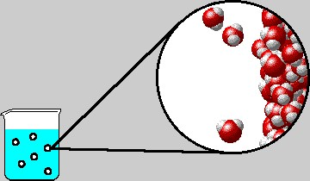

Animation 6.1: Chemical Bonding

Source & Credit: chemistry.elmhurst

### [6.](http://www.pbslearningmedia.org/)1.0 INTRODUCTION

A chemical bond is the force, which holds together two or more atoms or ions to form a large variety of compounds. The forces which are responsible for such bonding and the shapes of the molecules formed are as a result of chemical combination.



[*cal Bon*](http://www.pbslearningmedia.org/resource/lsps07.sci.phys.matter.chembonds/chemical-bonds/)

[*d*](http://www.pbslearningmedia.org/resource/lsps07.sci.phys.matter.chembonds/chemical-bonds/)

[*ningmedi*](http://www.pbslearningmedia.org/)

[*a*](http://www.pbslearningmedia.org/)

The theory of chemical bonding has been a major problem of modern chemistry. In this chapter, we shall look into the nature of the chemical bonds formed between the atoms.

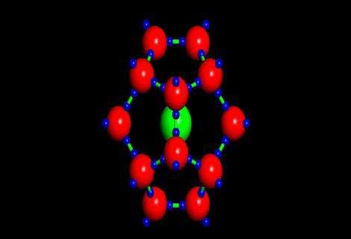

*Animation 6.2: Chemical Bond*

*Source & Credit :*

[*geo.arizon*](http://www.geo.arizona.edu/)

[*a*](http://www.geo.arizona.edu/)

**6.1.1 Cause of Chemical Combination**

It has been observed that the chemical reactivities of elements, depend upon their characteristic electronic conigurations. The noble gases with electronic coniguration of valence shell Is2 (He) or ns2 np6 (Ne, Ar, Kr, Xe, etc.) show little tendency to react chemically. There are just only a few stable compounds, formed by these elements like XeF2, XeF4, XeOF2, XeO3, etc. A noble gas does not react with another noble gas. Thus, these gases are the most stable of all the elements. Let us, see why noble gases are most stable. This can be explained on the basis of their special electronic coniguration. Their outermost s and p orbitals are completely illed.

|  |  |  |  |  |  |  |  |  |  |  |  |  |
| --- | --- | --- | --- | --- | --- | --- | --- | --- | --- | --- | --- | --- |
| ↿⇂ |  | ↿⇂ |  | ↿⇂ |  | ↿⇂ |  | ↿⇂ |  | ↿⇂ |  | ↿⇂ |

2He = Is 10Ne = Is 2s 2px 2py 2py 2pz

All other elements, combine with one another, due to an inherent tendency to stabilize themselves. They get their stabilization by losing, gaining or sharing electrons to attain the nearest noble gas coniguration. The tendency of atoms to attain a maximum of eight electrons in the valence shell is known as the ‘octet rule’. A few examples are given in Table (6.1).

In certain cases, both tendencies i.e. to lose or gain electrons have been observed. But the system will go by the conditions in which the chemical combination takes place. For example, in the chemical combination between sodium and hydrogen to form NaH, hydrogen atom gains an electron. In the formation of HF the hydrogen atom donates the major share of its electron to luorine atom.

Any how, the ‘octet’ rule could not be made universal as the formation of compounds PF5, SF6, BCl3 are not according to this rule.

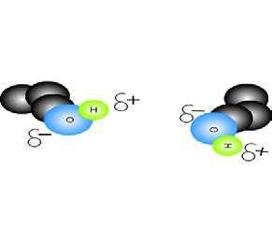

*Animation 6.3:*

[*bondin*](http://www.dynamicscience.com.au/)

[*g*](http://www.dynamicscience.com.au/)

*Source & Credit :*

[*dynamicscienc*](http://www.dynamicscience.com.au/)

[*e*](http://www.dynamicscience.com.au/)

#### Table (6.1) Change in the electronic conigurations of some elements after losing or gaining electrons

|  |  |  |  |  |
| --- | --- | --- | --- | --- |
| Element | Tendency | Electronic coniguration | | Nearest |
| Befor electron loss or gain | After electron loss or gain | nobel gas |
| Li  3 | Electron loss | 1s2 2s1 | 1s2 | He (2) |
| Mg  12 | Electron loss | 1s2 2s2 2p6 3s2 | 1s2 2s2 2p6 | Ne (10) |
| F  9 | Electron gain | 1s2 2s2 2px2 2py2 2pz1 | 1s2 2s2 2p6 | Ne (10) |
| S | Electron gain | 1s2 2s2 2p6 3s2 3p 2 3p 1 3p 1 | 1s2 2s2 2p6 3s2 3p6 | Ar (18) |

16 x y z

**6.1.2 ENERGETICS OF BOND FORMATION**

According to the modern theory of chemical bonding, atoms form bonds as it leads to a decrease in energy. For example, when two hydrogen atoms approach each other, forces of attraction and repulsion operate simultaneously.

The attractive forces tend to bring the two atoms close to each other and the potential energy of the system is decreased. On the other hand, the repulsive forces tend to push the atoms apart and potential energy of the system is increased. It has been found that the magnitude of potential energy for attractive forces is more than for repulsive forces. Therefore, potential energy decreases as the two hydrogen atoms approach each other Fig(6.1).

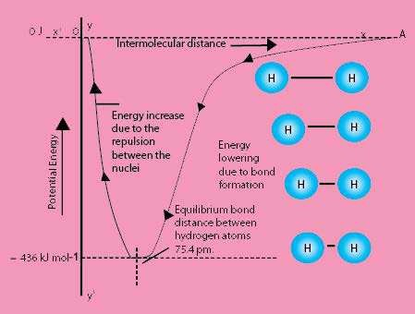

Fig: (6.1) Potential energy curve for the formation of H2 molecule.

Eventually, a state corresponding to the distance of 75.4pm is reached, where the attractive forces dominate the repulsive forces. Here,the potential energy of the system is minimum and the hydrogen atoms are said to be bonded to form a stable molecule. So,this distance of 75.4 pm is called bond distance or bond length or compromise distance of two hydrogen atoms. When the atoms approach the distance of minimum energy, then the system of two hydrogen atoms is stabilized to maximum extent. The amount of energy evolved is 436.45k.Jmol-1 and is called bond formation energy. In order to break the bond, the same amount of energy has to be provided.

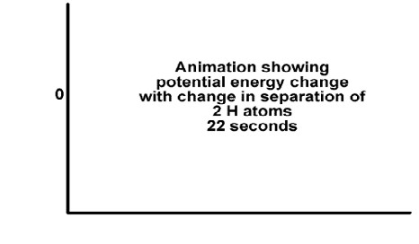

*Animation 6.4: ENERGETICS OF BOND FORMATION*

*Source & Credit :*

[*800mainstree*](http://www.800mainstreet.com/)

[*t*](http://www.800mainstreet.com/)

For the case, where repulsive forces are dominant than the attractive forces, the energy of the system increases and it leads to instability. Consequently, a bond is not formed. In order to understand bonding, the relative sizes of atoms should be known.

### 6.2. ATOMIC SIZES

**ATOMIC RADII, IONIC RADII AND COVALENT RADII.**

The size of an atom is very important because many physical and chemical properties are related to it. Atoms are assumed to be spherical. That is why, we report the various types of radii to guess their sizes For this reason, the sizes of atoms are expressed in terms of atomic radii, ionic radii and covalent radii, etc,. depending upon the type of the compound used for its measurement.

The atomic radius means the average distance between the nucleus of the atom and its outermost electronic shell.

The radius of an atom cannot be determined precisely due to the following reasons.

1. There is no sharp boundary of an atom. The probability of inding an electron never becomes exactly zero even at large distances from the nucleus.
2. The electronic probability distribution is afected by neighbouring atoms. For this reason,the size of an atom may change from one compound to another.

Atomic radii can be determined, by measuring the distances between the centres of adjacent atoms with the help of X-rays or by spectroscopic measurements. Atomic radii of elements of the periodic table in pm are shown in Table (6.2).

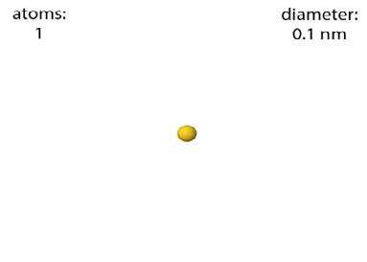

*Animation 6.5: ATOMIC SIZES*

*Source & Credit : sustainable-nano*

**Variation of Atomic Radii in the Periodic Table**

In general, the atomic radii decrease from left to the right in a period and increase from top to bottom in a group of the periodic table. The decreasing trend in a period is due to the increase in the nuclear charge. As the nuclear charge increases, the pull on the electrons is increased and size of an atom decreases. Moreover, the shielding efect remains the same from left to right in a period.



*Animation 6.6: Periodic trends*

*Source & Credit : kaiserscience.wordpress*

The increase in atomic radii in a group is due to increase in the number of shells and the screening efect. The decrease of atomic radii is very prominent in second period, but less in higher periods. Moreover, the decrease is small, when we travel from left to right in transition elements Sc(21) -Zn(30), Y(39) -Cd(48) due to the intervening electrons. The screening efect is also called shielding efect. This is responsible for the decrease in force of attraction of the nucleus for the electrons present in the valence shell.

**Table (6.2) Radii of atoms and ions in the periodic table.**

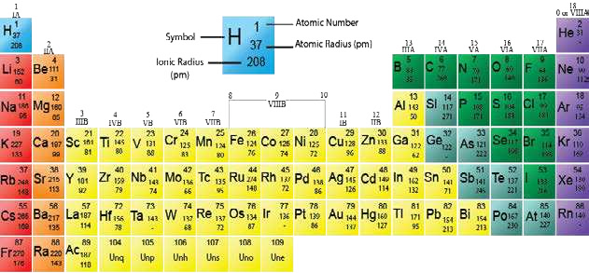

**6.2.1 Ionic Radii and Covalent Radii**

**Ionic Radic**

The ionic radius of an ion is the radius of the ion while considering it to be spherical in shape. The ionic radii of some ions in pm are given in Table (6.2). The ionic radius of a cation is smaller than the atomic radius of the element from which it is derived. The ionic radius of an anion is greater than the atomic radius of the corresponding atom. The radius of Na atom, for example, reduces from 186 pm to 95 pm after conversion into Na+ ion. The ionic radius of Cl- ion increases from 99 pm to 181 pm. The cationic radius decreases with the increase in the efective nuclear charge on the ion. The decrease in radius is larger for divalent ions (Mg2+) and still larger for trivalent ions (Al3+). This is due to the reason that with the successive loss of electrons, the nuclear charge attracts the remaining electrons with a greater force.

The increase in the size of the anion is due to the increase in the electron-elenctron repulsion because of the increase in the valence shell electrons. Greater the amount of negative charge on an atom, greater the size of ion.

The variation of ionic radii in groups and periods have the same trend as for atomic radii. But keep in mind that ionic radius for metals is for positive ions and for elements of group number VA to ViiA are for negative ions.

Let us consider, the positive and negative ions, which are held together by electrostatic forces of attraction in a crystal lattice. Fig. (6.2), r+ and r- are the values of radii of cation and anion, respectively.

The interionic distance ‘R’ in a crystal lattice is equal to the sum of the cationic radius r+ and the anionic radius r.

R = r+ + r-

Pauling was able to determine the distance between K+ and Cl- ions in potassium chloride crystal and found that it was equal to the sum of the radii of the two ions.

R = 133pm + 181 pm = 314 pm

Thus, the ionic radius appeared to be an additive property. Pauling extended this concept to other K+ salts and calculated the radii of other ions from the relationship:

r- = R - r+

Similarly, the ionic radii of diferent cations can also be determined.

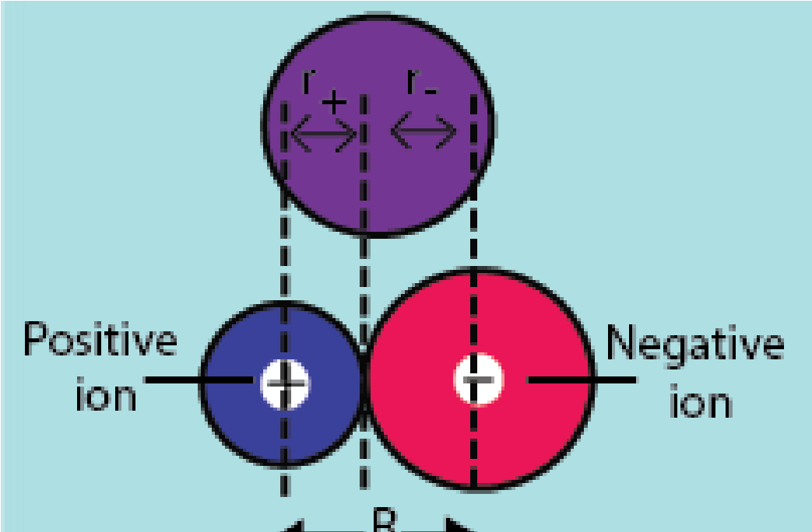F. ig (6.2) The relationaship of interionic distance R and ionic. radii (r+ and r- )

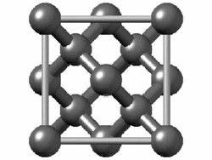

*Animation 6.7: Ionic Radii and Covalent Radii Ionic Radii*

*Source & Credit : chemwiki.ucdavis*

**Covalent Radii**

The covalent radius of an element is deined as half of the single bond length between two similar atoms covalently bonded in a molecule.

The covalent radius of hydrogen, for example, is 37.7 pm. It is half of the single bond length (75.4 pm) between the two H atoms in H-H molecule, as shown in Fig (6.3).

The covalent radius of an atom can be used to determine the covalent radius of another atom. For example, the experimentally determined bond length of C-Cl in CH3CI is 176.7 pm. The covalent radius of Cl-atom being known as 99.4 pm, that of C-atom can be calculated by subtracting this value from C-Cl bond length. So, the covalent radius of C-atom = 176.7- 99.4 = 77.3 pm.

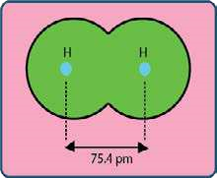

Fig (6.3) Covalent radius of H atom, (75.4/2 = 37.7 pm)

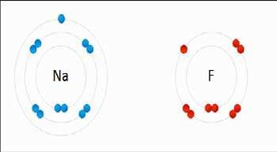

*Animation 6.8: Covalent Radii*

*Source & Credit :*

[*boundles*](http://www.boundless.com/)

[*s*](http://www.boundless.com/)

The variation of covalent radii in groups and periods is almost the same as of atomic radii. Since energy changes are involved in the bond formation, so thermodynamic properties of elements need to be discussed before understanding the chemical bond.

**6.3 IONIZATION ENERGY, ELECTRON AFFINITY AND**

### ELECTRONEGATIVITY

**6.3.1 Ionization Energy**

The ionization energy of an element is the minimum energy required to remove an electron from its gaseous atom to form an ion. The process is called ionization, e.g.

Mg → Mg +e+ - ∆H=738kJmol-1

#### Table (6.3) First ionization energies, electron afinities and electronegativities values of elements

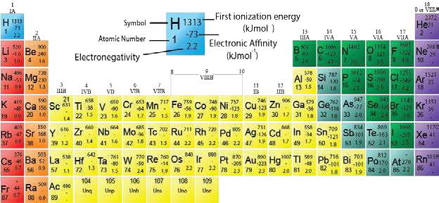

In the gaseous phase, the atoms and ions are isolated and are free from all external inluences. Thus, the ionization energy is the qualitative measure of the stability of an isolated atom. The irst ionization energies of elements are given in Table (6.3).

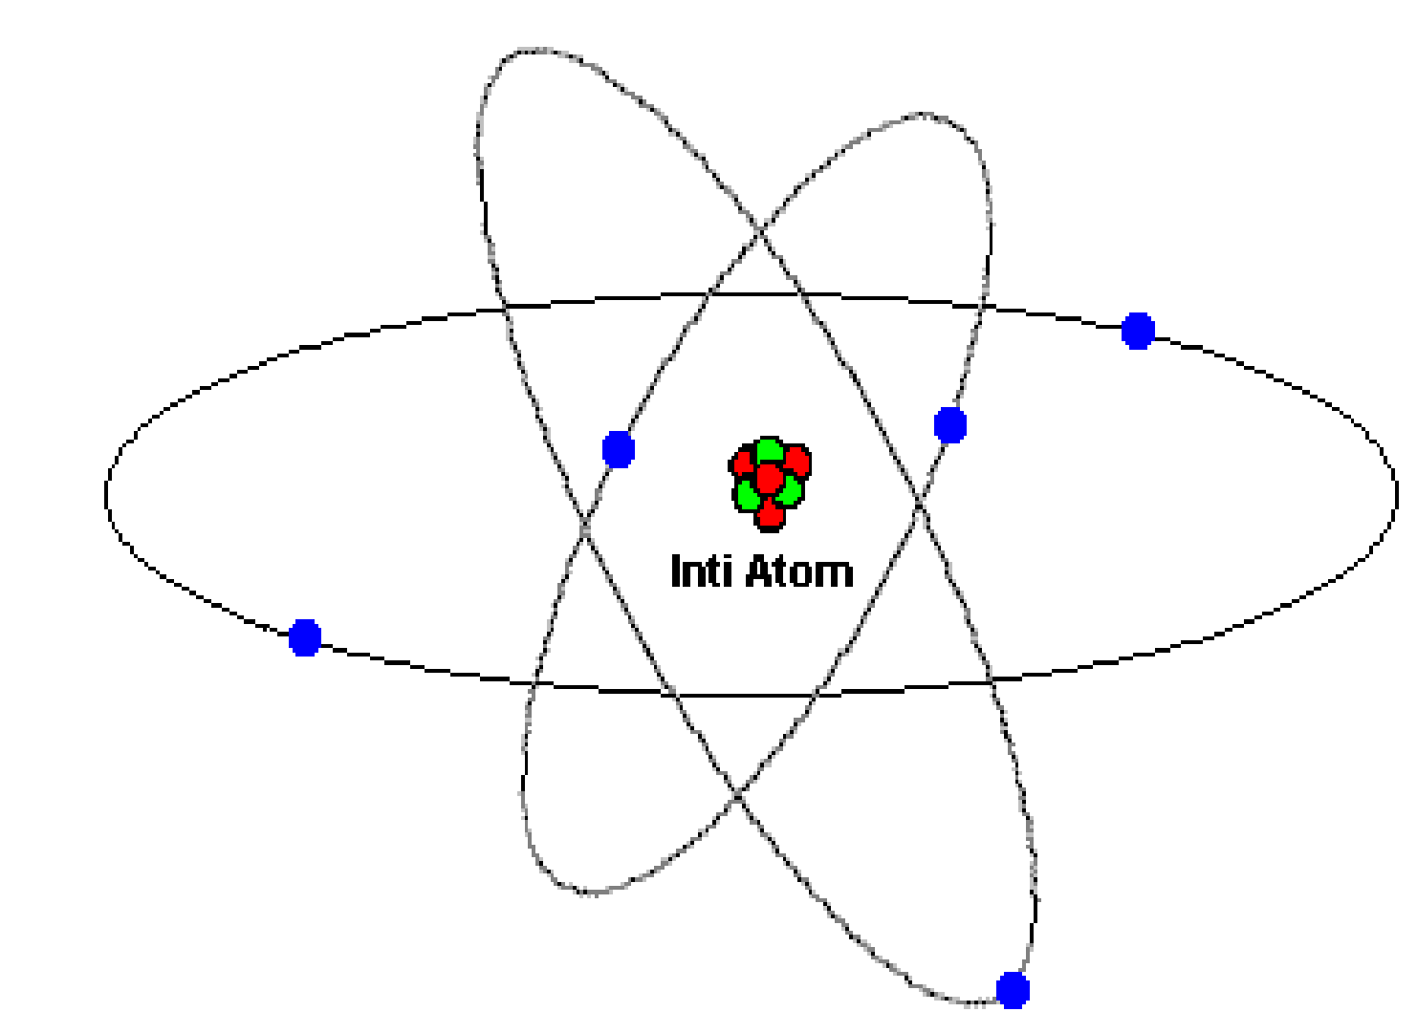

*Animation 6.9: Ionization Energy*

*Source & Credit : kaiserscience.wordpress*

#### Factors Inluencing the Ionization Energies

It is observed that the ionization energies of atoms depend upon the following factors. (i) Atomic radius of atom

1. Nuclear charge or proton number of the atom
2. Shielding efect of inner electrons
3. Nature of orbital

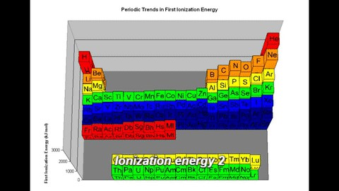

*Animation 6.10: Factors Inluencing the Ionization Energies*

*Source & Credit : kaiserscience.wordpress*

**Variation of Ionization Energy in the Periodic Table**

In the periodic table, the ionization energies increase from left to right in a period with the increase in the proton number, until a maximum value is reached at the end of the period. This may be explained in terms of the periodicity of the electronic coniguration of elements. Each period begins with an element which has one electron in its valence shell and ends with the completion of an electronic shell. The increase in the atomic number is associated with the increase in nuclear charge which leads to a stronger force of attraction between the nucleus and the increasing number of electrons. The stronger force of attraction, ultimately results in diicult removal of electrons. In groups, the ionization energy decrease in spite of the increase in proton number or nuclear charge. This is due to successive addition of electronic shells as a result of which the valence electrons are placed at a larger distance from the nucleus. As the force of attraction between the nucleus and the outer electron decreases with the increase in distance, the electron can be removed more easily or with less energy. Moreover, the force of attraction also decreases due to increasing shielding efect of the intervening electrons.

The ionization energies of group III-A and VI-A show abnormal trend. This can be understood from the distribution of the electrons.

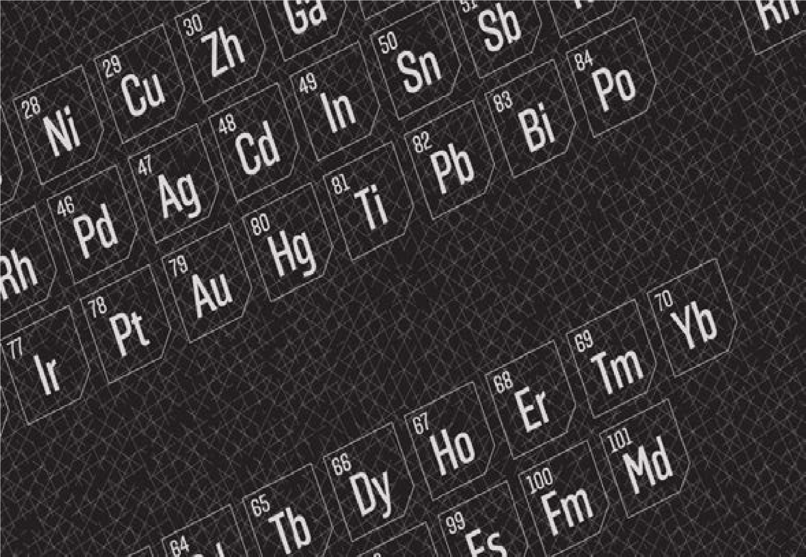

*Animation 6.11: Variation of Atomic Radii in the Periodic Table*

*Source & Credit :*

[*dynamicscienc*](http://www.dynamicscience.com.au/)

[*e*](http://www.dynamicscience.com.au/)

**Higher Ionization Energies**

So far, we have explained the irst ionization energy. The energy required to remove an electron after the removal of irst electron is called second ionization energy.

Mg → Mg++ +e- ∆H=1450kJmol-1

Similarly, the energy required to remove third electron after the removal of second one is called the third ionization energy, and it is 7730kJ for Mg. It means that the ionization energy values undergo an increase with the increase in the number of electrons to be removed. This is due to the reason that second electron is removed from a positively charged ion rather than a neutral atom. The dominant positive charge holds the electrons more tightly and thus further removal of electrons becomes more diicult.

Ionization energy is an index to the metallic character. The elements having low ionization energies are metals and those having high ionization energies are non-metals. Those with intermediate values are mostly metalloids.

The gaps in the irst, second, third and higher ionization energies help us to guess the valency of an element. If, there is suicient gap between irst ionization energy and second one, then the element shows valency of one.

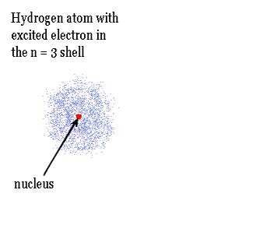

*Animation 6.12: Higher Ionization Energies*

*Source & Credit :*

[*800mainstree*](http://www.800mainstreet.com/)

[*t*](http://www.800mainstreet.com/)

##### 6.3.2 Electron Afinity

The electron ainity of an atom is the energy released when an electron adds to an empty or partially illed orbital of an isolated gaseous atom in its valence energy level to form an anion having a unit negative charge, e.g.

Cl g +e( ) - →Cl- ( )g ∆H=-349kJmol-1

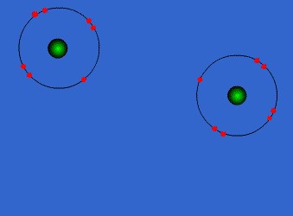

*Animation 6.13: Electron Afinity*

*Source & Credit : hcchrisp.blogspot*

Since, energy is released, so electron ainity is given the negative sign. Electron ainity is the measure of the attraction of the nucleus of an atom for the extra electron. The electron ainities of elements of the periodic table are given in Table (6.3).

#### Factors Inluencing the Electron Afinity

The electron ainities, like ionization energies, are inluenced by the factors such as atomic radius, the nuclear charge and the shielding efect of inner electrons.

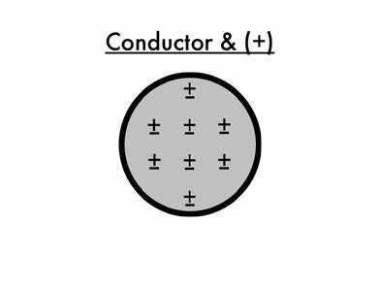

*Animation 6.14: Factors Inluencing the Electron Afinity*

*Source & Credit :*

[*northhillspre*](http://www.northhillsprep.org/)

[*p*](http://www.northhillsprep.org/)

As the force of attraction between the valence electrons and the nucleus decrease with the increase in the atomic radius, the electron ainities usually decrease.

**Variation in the Periodic Table**

In a period, the atomic radius decreases due to increase in the nuclear charge. Thus, the electron ainities of elements increase from left to right in the periodic table. That is why, the alkali metals have the lowest and the halogens have the highest electron ainities. In groups, on the other hand, the atomic radii increase with the increase in the proton number due to successive increase of electronic shells.

This also exerts a shielding efect on the force of attraction between the nucleus and the valence electrons. Thus, the electron ainities usually decrease from top to bottom.

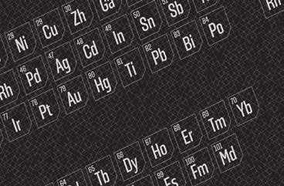

*Animation 6.15: Variation in the Periodic Table*

*Source & Credit :*

[*vocati*](http://www.vocativ.com/)

[*v*](http://www.vocativ.com/)

There are, of course, exceptions to this generalization e.g. luorine has electron ainity less than that of chlorine, Table (6.3). Actually, luorine has very small size and seven electrons in 2s and 2p subshells have thick electronic cloud. This thick cloud repels the incoming electron.

The elements of group IIA, VA and VIII show abnormally low values in every period of the periodic table. This can be understood from their electronic conigurations.

**6.3.3 Electronegativity**

For a homonuclear diatomic molecule e.g. H2, the bonding pair of electrons is equally shared between the atoms. On the other hand, in a bond between dissimilar atoms such as in HF the electron density of the bonding electrons lies more towards the luorine atom than towards the hydrogen atom. The tendency of an atom to attract a shared electron pair towards itself is called its electronegativity.

It is related to the ionization energy and the electron ainity of the element. Thus, luorine atom is more electronegative than hydrogen atom. Pauling calculated the electronegativity values of elements from the diference between the expected bond energies for their normal covalent bond and the experimentally determined values.

He devised an electronegativity scale on which luorine is given an arbitrary standard value 4.0. It is the most electronegative element. The electronegativity values of other elements are compared with luorine, and are given in Table (6.3). Electronegativity has no units.

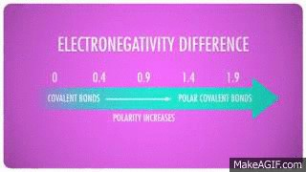

*Animation 6.16: Electronegativity*

*Source & Credit : makeagif*

**Variation of Electronegativities in Periodic Table**

A comparison of electronegativities shows that the values increase in a period with the decrease in atomic size. These values decrease in a group as the size of the atoms increase. The electronegativity diferences of the elements can be related to the properties of bonds such as dipole moments and bond energies.

The diference in the electronegativity values of the bonded atoms is an index to the polar nature of the covalent bond. When the diference is zero, the bond between the two atoms is non-polar. Thus, all the bonds which are formed between similar atoms are nonpolar in character, while those formed between diferent elements are mostly polar. Elements of widely diferent electronegativities form ionic bonds.

A diference of 1.7 units shows roughly equal contributions of ionic and covalent bonds. Some examples of polar and non-polar bonds are discussed under covalent bond in section 6.4.1.

Having understood the periodic properties of elements, let us discuss types of bonds.

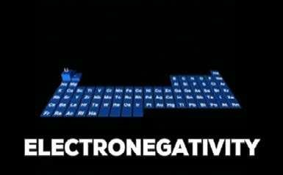

*Animation 6.17: Variation of Electronegativities in Periodic Table*

*Source & Credit : kaiserscience.wordpress*

### 6.4 TYPES OF BONDS

Chemical bonds can be classiied as :

1. Ionic bond
2. Covalent bond
3. Coordinate covalent bond

We shall explain these bonds with the help of diferent theories of chemical bonding. First of all let us discuss the Lewis concept of bond formation.

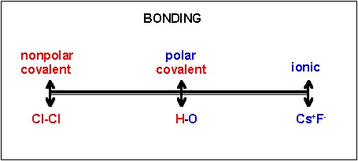

*Animation 6.18: TYPES OF BONDS*

*Source & Credit : employees.csbsju*

**6.4.1 LEWIS CONCEPT**

With the help of this concept, we can understand the tendencies of elements to have relation with each other.

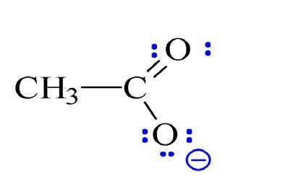

*Animation 6.19: LEWIS CONCEPT*

*Source & Credit :*

[*nk*](http://www.nku.edu/)

[*u*](http://www.nku.edu/)

**(i) Ionic Bond**

**According to the Lewis theory, ionic bond is formed by the complete transfer of electron or electrons from an atom with low ionization energy to another atom with high electron ainity.** In energy terms, the electropositive elements are at a higher energy state than the electronegative elements. The energy diference will be responsible for the transfer of electrons from a higher energy state to a lower energy state.

Let us consider, the example of the formation of potassium chloride. The electronic coniguration of potassium is Is2 2s2 2p6 3s2 3p6 4s1. It may be represented as K (2,8,8,1). It tends to lose the outermost electron and to form K+ ion. The energy needed to detach an electron from potassium atom is equal to its irst ionization energy. So

+ −

K(2,8,8,1) → K (2,8,8) + e ∆H=419.0kJmol-1

The oppositely charged K+ and Cl- ions are held together by strong electrostatic force of attraction. K+ and Cl- ions arrange themselves to form a crystal lattice where proportionate number of cations and anions are packed together. The energy released during the formation of crystal lattice is 690 kJmol-1. It is called lattice energy of KCl.

After the loss of an electron, potassium attains the nearest inert gas coniguration of Ar (2,8,8). Chlorine atom has the electronic coniguration Is2 2s2 2p6 3s2 3p5 or Cl (2,8,7). It tends to gain electron lost from potassium atom to attain the nearest inert gas coniguration of Ar (2,8,8) releasing 348.6 kJmol-1 energy. This energy corresponds to the electron ainity of chlorine.

:Cl ⋅+*e*− →:Cl − : ∆H=-349kJmol-1

 

Similarly, the elements of I-A Li, Na, K, Rb, Cs are good losers of electron. The elements of VII-A, F, Cl, Br, I are good gainers. So, ionic bonds are there in these atoms. A similar type of bond is expected between elements of group II-A and VI-A.

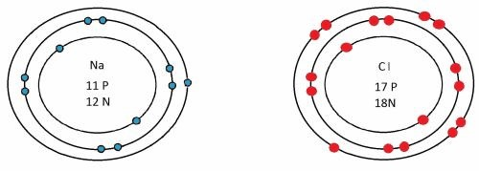

*Animation 6.20: Ionic Bond*

*Source & Credit : gcsechemistryhelp.tumblr*

In most of the cases the formation of dipositive, tripositive and dinegative ions takes place as follows:

**Ca (2,8,8,2)**  **Ca2+ (2,8,8)+2e Al (2,8,3)**  **Al3+ (2,8)+3e-**

**O (2,6) + 2e-**  **O2- (2,8)**

**S (2,8,6) + 2e-**  **S2- (2,8,8)**

Calcium oxide contains ions in the ratio of Ca2+ : O2- and its formula is CaO, while in aluminium oxide, Al3+ and O2- ions are present in the ratio 2 :3. Its formula is Al2 O3. Similarly, CaS and Al2S3, are also ionic compounds to some extent.

The compounds formed by the cations and anions are called ionic or electrovalent compounds. There exists a strong electrostatic force of attraction between cations and anions in these compounds.

Criteria of electronegativity also helps us to understand the nature of bond. So, in order to decide the % of ionic nature in a compound, it is better to note the diference of electronegativity between the bonded atoms. If the diference is 1.7 or more than that, then the bond is said to be ionic. Keeping this aspect in view, NaCl has 72% ionic character. CsF has 92% ionic character and calculations tell us that there is no bond with 100% ionic character.

**(ii) Covalent Bond (electron pair bond)**

According to Lewis and Kossel, a covalent bond is formed by the mutual sharing of electrons between two atoms. While sharing, each atom completes its valence shell and attains the nearest inert gas coniguration. A covalent bond may be non-polar or polar in character.

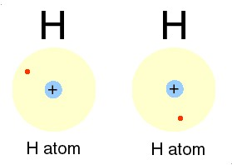

*Animation 6.21: Covalent Bond (electron pair bond)*

*Source & Credit :*

[*edcoogl*](http://www.edcoogle.com/)

[*e*](http://www.edcoogle.com/)

**Non-Polar Covalent Bonds**

In such bonds, the bonding electron pairs are equally shared. For example, in H2 or Cl2 molecules, the two electrons forming the covalent bond are equally shared by the two identical atoms having same electronegativities.

|  |
| --- |
| **Chlorine** |

**Hydrogen**

xx

H : H or H - H :Cl x. Clxx xx or Cl----Cl

Due to an even distribution of charge, the bonded atoms remain electrically neutral.The other such molecules are F2, Br2 and I2.Similarly, CCl4 is a non-polar compound. This is due to cancellation of all the dipoles of this molecules due to its symmetry. Actually, all the C-Cl bonds are polar, but molecule is non-polar overall.



*Animation 6.22: Non-Polar Covalent Bonds*

*Source & Credit :*

[*bsc2.ehb-schweiz*](http://www.bsc2.ehb-schweiz2.ch/)

[*2*](http://www.bsc2.ehb-schweiz2.ch/)

**Tetrachloromethane**

:Cl :

Cl

Cl

C

Cl

Cl

 :C: Cl: or

:Cl

    :Cl :

The molecules like CH4, SiH4, and SiCl4 also follow the same attitude of non-polarity due to symmetry of structure.

**Polar Covalent Bonds**

When two diferent atoms are joined by a covalent bond, the electron pair is not equally shared between the bonded atoms. The bonding pair of electrons will be displaced towards the more electronegative atom

This would make one end of the molecule partially positive and the other partially negative as shown by the following examples.

**Hydrogen fluoride**

|  |
| --- |
| **Water** |

|  |  |
| --- | --- |
| δ+ H or | Oδ+    Hδ+ |

H×F: or Hδ+x F δ- H×O×H 

**Methyl chloride**

H..

H

δ+

C

H

H

δ-

Cl

.xClxx xx or

H: C

xx

#### H

Methanol is an other best example of a polar covalent molecule, because it contains a polar bond.

**Methanol**

H  xx

H

H

δ+

C





δ-

O

H

δ-

H

H: C xO xH or

.

.

xx H

An atom can share more than one electrons to form what is called a double or triple bond. The examples are O2, N2, CO2, CS2, etc.

N2 is an inert gas having a strong triple bond.

**Nitrogen**

:N:::N:or :N ≡N:

The molecule: of 02 makes a double bond.

**Oxygen**

O::O  or O=O  

Here, carbon dioxide is a non-polar covalent compound, although it is formed from heteroatoms. The linear structure balances the polar character on both sides of the carbon atom.

**Carbon dioxide**

:O::C::O :or O=C=O 

Here, each bond represents a pair of electrons. Thus, in the formation of a double bond (=), two shared pairs and in that of a triple bond (≡), three shared pairs of electrons are involved.

Some of the non-metallic atoms, particularly carbon atoms mutually share their electrons with each other. This leads to the formation of extended chains which is the basis of the formation of large sized molecules called macromolecules. Diamond, graphite and SiC are the best examples of such molecules.

Carbon can make single, double and triple covalent bonds in alkanes, alkenes and alkynes.

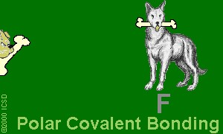

*Animation 6.23: Polar Covalent Bonds*

*Source & Credit :*

[*bsc2.ehb-schweiz*](http://www.bsc2.ehb-schweiz2.ch/)

[*2*](http://www.bsc2.ehb-schweiz2.ch/)

**Ethan**

H H

H

H

H

C

C

H

H

H

H :C: C: H

H H or

Silicon also gives similar type of hydrides, called silanes. The formula of disilane is like that of ethane.

**Disilane**

H H

H

H

H

Si

Si

H

H

H

H :Si: Si: H or

### H H

The compounds of carbon and hydrogen showing double and triple bonds are called alkenes and alkynes. Let us, take the examples of ethene and ethyne.

|  |  |  |  |
| --- | --- | --- | --- |
| |  | | --- | | **Ethan** | | |  | | --- | | **Ethan** | |

H

H

C=C

H

H

H H

::C: :C:: or H:C C:H or H-C ≡ C-H H H

**(iii) Coordinate Covalent Bond**

A coordinate covalent bond is formed between two atoms when the shared pair of electrons is donated by one of the bonded atoms. Let us consider, the example of bond formation between NH3 and BF3. NH, has three covalent bonds and there is a lone pair of electrons on nitrogen atom. On the other hand, boron atom in BF3 is deicient in electrons. Actually, the octet of B is not complete in BF3. Therefore, nitrogen can donate the pair of electrons to the acceptor BF3 and this results in the formation of a coordinate covalent bond.

The complex so produced is overall neutral, and charges are indicated on N and B atoms. In some of the compounds, after the formation of a coordinate covalent bond, the distinction between covalent bond and coordinate bond vanishes.

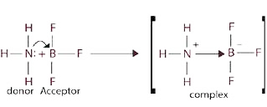

Water donates its electron pair to H+ ion to give H30+ ion. All the three bonds between oxygen and hydrogen have equal status. Every bond is 33% coordinate covalent and 66% covalent.

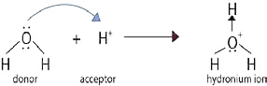

Similarly, all the alcohols and ethers ofer their lone pairs to H+, just like water to give coordinate covalent bonds. The ions so produced are called oxonium ions.

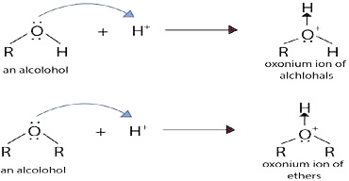

Ammonia donates its electron pair to H+ ion to give NH4+ ion. All the four bonds behave alike, in NH4+ion.

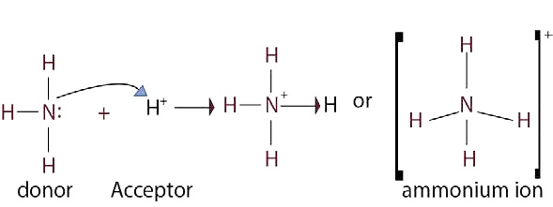

All the primary, secondary and tertiary amines like ammonia make such bonds with H+. PH3 combines with H+ to give PH4+ ion called phosphonium ion. Coordinate covalent bonds are present in HNO3. Many oxyacids of halogens, like (HClO2, HClO3, HClO4) have coordinate covalent bonds between chlorine and oxygen.

**6.4.2 MODERN THEORIES OF COVALENT BOND**

**Limitations of Lewis Model**

Classical Lewis model does explain, that how atoms are bonded to one another. It also tells, how the electron pairs are shared between the bonded atoms. But a logical question arises:

Are these explanations just enough to justify the diversiied world of molecules and how do the electrons avoid each other inspite of their repulsions?

The answer simply lies in the fact, that the Lewis model seems to be an over simpliication. Shapes of molecules are very important because many physical and chemical properties depend upon three dimensional arrangement of their atoms.

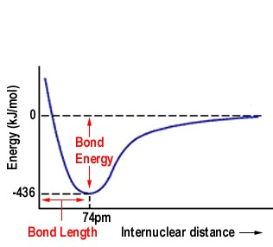

*Animation 6.24: MODERN THEORIES OF COVALENT BOND*

*Source & Credit :*

[*chem.umas*](http://www.chem.umass.edu/)

[*s*](http://www.chem.umass.edu/)

A true model should be able to justify molecular shapes and geometries of molecules, bond polarities, bond distances and various energy transitions as evident by spectroscopic techniques. This model should also make clear the unique behaviouria! features of molecules during chemical reactions.

Following are the modern theories, which explain satisfactorily the above requirements for covalent bond formation, based on wave-mechanical structure of atoms:

1. Valence shell electron pair repulsion theory (VSEPR Theory)
2. Valence bond theory (VBT)
3. Molecular orbital theory (MOT)

In addition to above, crystal ield theory and ligand ield theory explain the formation of coordination complex compounds formed by transition metals.

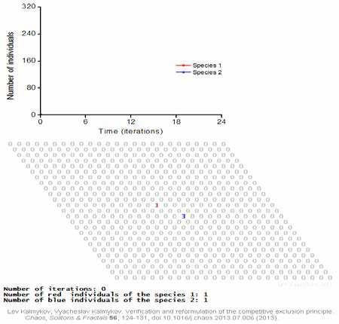

*Animation 6.25: Limitations of Lewis Model*

*Source & Credit : en.wikipedia*

**6.4.3 VALENCE SHELL ELECTRON PAIR REPULSION THEORY**

Sidgwick and Powell (1940) pointed out that the shapes of molecules could be interpreted in terms of electron pairs in the outer orbit of the central atom. Recently, Nylholm and Gillespie developed VSEPR theory, which explains the shapes of molecules for non- transition elements.

**Basic Assumption**

The valence electron pairs (lone pairs and the bond pairs) are arranged around the central atom to remain at a maximum distance apart to keep repulsions at a minimum.

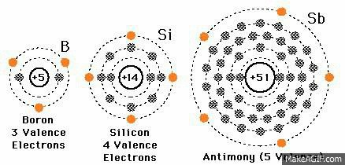

*Animation 6.26: VALENCE SHELL ELECTRON PAIR REPULSION THEORY*

*Source & Credit : barmaton.info*

**Postulates of VSEPR Theory**

1. Both the lone pairs as well as the bond pairs participate in determining the geometry of the molecules.
2. The electron pairs are arranged around the central polyvalent atom so as to remain at a maximum distance apart to avoid repulsions.
3. The electron pairs of lone pairs occupy more space than the bond pairs.

A bonding electron pair is attracted by both nuclei of atoms while non- bonding by only one nucleus. Because a lone pair experiences less nuclear attraction, its electronic charge is spread out more in space than that for bonding pair. As a result, the non- bonding electron pairs exert greater repulsive forces on bonding electron pairs and thus tend to compress the bond pairs.

The magnitude of repulsions between the electron pairs in a given molecule decreases in the following order:

Lone pair- lone pair > lone pair -bond pair > bond pair - bond pair

These repulsions are called van der Waals repulsions

(iv) The two electron pairs of a double bond and three electron pairs of a triple bond, contain a higher electronic charge density. Therefore, they occupy more space than one electron pair of a single bond, but behave like a single electron pair in determining the geometry of the molecule. This is because, they tend to occupy the same region between the two nuclei like a single bond. In order to illustrate this theory, let us consider, that the central atom is ‘A’ and this atom is polyvalent. More than one ‘B’ type atoms are linked with ‘A’ to give AB2, AB3, AB4, etc. type molecules. It depends upon the valency of A, that how many B are attached with that. Following Table (6.4) gives the shapes of diferent types of molecules.

#### Table (6.4) Shapes of molecules according to VSPER Theory

|  |  |  |  |  |  |  |  |
| --- | --- | --- | --- | --- | --- | --- | --- |
| Type | Electron Pairs | | | Arrangement of pairs | Molecular geometry | Shape | Example |
| Total | Bonding | Lone |
| AB2 | 2 | 2 | 0 | Linear | Linear | B-A-B | BeCl2 HgCl2 |
| AB3 | 3 | 3 | 0 | Trigonal planar | Trignol planar |  | BH3, BF3 AlCl3 |
| 2 | 1 | Bent (or angular) |  | SnCl2,  SO2 |
| AB4 | 4 | 4 | 0 | Tetrahedral | Tetrahedral |  | CH4,  SiCl4,  CCl4, BF4,  NH4+, SO42- |
|  |  |  |  |  |
|  |  | 3 | 1 |  | Trignol pyramidal |  | NH3, NF3, PH3 |
| 2 | 2 | Bent (or angular |  | H2O, H2S |

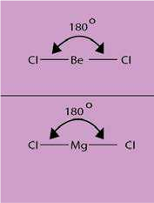**1 Molecules Containing Two Electron Pairs (AB2 type)**

In such, molecules two electrons, pairs around the central atom are arranged at farther distance apart at an angle of 180°, in order to minimize repulsions between them. Thus, they form a linear geometry.

Beryllium chloride is a typical linear molecule, which contains two electrons pairs. MgCl2, CaCl2, SrCl2. CdCL2 and HgCl2 are also linear molecules. The central atoms have two electrons in outer most orbitals.

**2. Molecules Containing Three Electron Pairs — (AB3 type:)**

1. **AB3 Type with no Lone Pairs**

In such molecules, central atom contains three bonding electron pairs, which are arranged at maximum distance apart at a mutual angle of 120°, giving a triangular planar geometry. The boron atom in BH3 is surrounded by three charge clouds, which remain farthest apart in one plane, each pointing towards the corners of an equilateral triangle. Thus, BH3, molecules has a trigonal planar geometry, with each H- B-H bond angles of 120°.

We expect similar geometries in hydrides of group III-A (AlH3, GaH3, InH3 and TlH3)and their halides (BF3, AlCl3 ,etc.)

1. **AB3-Type with One Lone Pair and Two Bond Pairs**

In SnCl2, one of the corner of the triangle is occupied by a lone pair, giving rise to a distorted triangular structure in vapour phase.

1. **AB3-Type with Multiple Bonds**

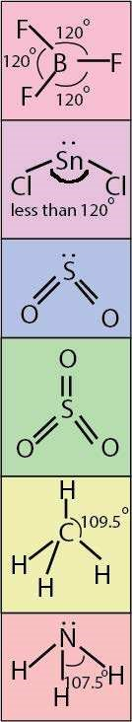 In SO2, one corner of triangle is occupied by a lone pair and two corners each by S=O double bond, while in SO3 all three regions, each are occupied by S = O bonds. This structure of SO3 is perfectly triangular.

**(iii) Molecules Containing Four Electron Pairs (AB4- Type:)**

**(a) AB4 Type with no Lone Pairs**

The charge clouds due to four electron pairs avoid their electrostatic repulsions by drifting apart, so as to maintain a mutual bond angle of 109.5 °.

Such geometry enables to a form a shape of regular tetrahedron.

**Examples:**

Each of the four valence electrons of carbon pair up with sole electron of hydrogen in methane.

6C = 1s , 2s , 2px , 2py , 2py2 1 1 1 1

The four electron pairs are directed from the center towards the corners of a regular tetrahedron, with each apex representing a hydrogen nucleus. The arrangement permits a non-planar arrangement of electron pairs. Each H-C-H bond is perfectly 109.5 °. On the same grounds, SiH4, GeH4, CCl4 form similar geometries. This structure has four corners, four faces, six edges and six bond angles.

1. **AB4 - Type with One Lone Pair and Three Bond Pairs**

In such cases, the charge cloud of lone pair electrons (nonbonding electrons) spreads out more than that of bonding electrons.

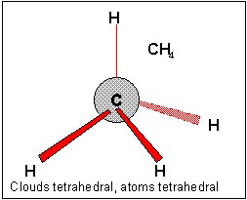

*Animation 6.27: Molecules Containing Two Electron Pairs (AB2 type)*

*Source & Credit : employees.csbsju*

As a result, some what large lone pair charge cloud tend to compress the bond angles in rest of the molecules.

Ammonia, NH 3 is a typical example.

7 N = 1s , 2s , 2p , 2p , 2p2 2 x1 y1 z1

The non-bonding electron in 2s orbital takes up more space and exerts a strong repulsive force on the bonding electron pairs. Consequently, to avoid a larger repulsion, the bonding electron pairs move closer that reduces the ideal bond angle from 109.50 to 107.5°. This efect compels ammonia to assume a triangular pyramidal geometry instead of tetrahedral, as in methane. Similar, afects are evident in the geometries of molecules like PH , AsH , SbH3  3  3 and BiH 3 . Substitution of hydrogen with electronegative atoms like F or Cl further reduces the bond angle. In NF3, the strong polarity of N-F bond pulls the lone pair of N atom closer to its nucleus, which in turn exerts a stronger repulsion over bonding electrons. Thus, the angle further shrinks to 102°. Moreover, the bond pairs N-F bonds are more close to F atoms than N atoms. The increased distances in these bond pairs makes their repulsions less operative.

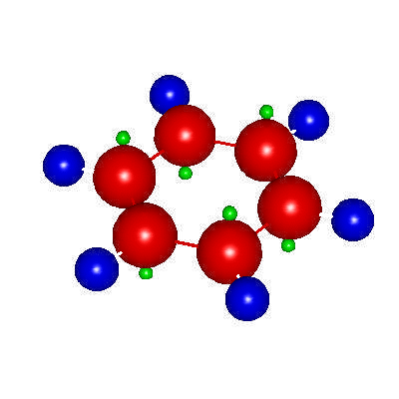

*Animation 6.28: Molecules Containing Three Electron Pairs — (AB;i type:)*

*Source & Credit :*

[*nano-o*](http://www.nano-ou.net/)

[*u*](http://www.nano-ou.net/)

1. **AB4-Type with Two lone Pairs and Two Bond Pairs:**

Presence of two lone pairs, introduces three types of repulsion i.e. lone pair-lone pair, lone pair-bond pair and bond pair-bond pair repulsion. For example: water (H2O), a triatomic molecule is expected to be an AB2 type linear molecule like BeCl2 and CO2. But, experimental evidences conirm a bent or angular geometry. VSEPR theory, successfully justiies the experimental results by arguing the participation of lone pairs, in addition to bond pairs in determining overall geometry of water molecule.

8O = 1s , 2s , 2p2 2 2x , 2p , 2p1y 1z

Two of the corners of a tetrahedron are occupied by each of the two lone pairs and remaining by bond pairs. But owing to spatial arrangement of lone pairs and their repulsive action among themselves and on bond pairs, the bond angle is further reduced to 104.5°. H2S, H2Se, H2Te form similar geometries.

**6.4.4 Valence Bond Theory (VBT)**

VSERP theory predicts and explains the shapes of molecules but does not give reasons for the formation of bonds. VBT is concerned with both the formation of bonds and the shapes of molecules. This method of describing a covalent bond considers the molecule as a combination of atoms. According to the quantum mechanical approach, a covalent bond is formed when halfilled orbitals in the outer or valence shells of two atoms overlap, so that a pair of electrons, one electron from each atom, occupies the overlapped orbital, As a result of this overlap, the electrons with opposite spins become paired to stabilized themselves.

Larger the overlap, the stronger is the bond. The essential condition for chemical bonding, is that the orbitals of atoms participating in bond formation must overlap and the direction of the bond is determined by the direction of the two overlapping orbitals.

The formation of few molecules as a result of s and s orbital overlap, s and p orbital overlap and p and p orbital overlap are discussed below.

The formation of a hydrogen molecules according to VB theory is shown in Fig. (6.4). As the two atoms approach each other, their 1s orbitals overlap, thereby giving the H-H bond.

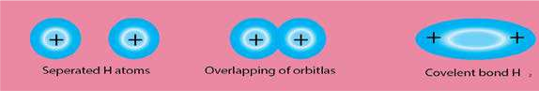

Fig. (6.4) s and s orbital overlap in H2

The electron density becomes concentrated between the two nuclei. The bond is called a sigma (s) bond and it is deined as follows:

A single bond is formed when two partially illed atomic orbitals overlap in such a way that the probability of inding the electron is maximum around the line joining the two nuclei.

Let’s look at a molecule hydrogen luoride, HF. The H-F bond is fomed by the pairing of electrons - one from hydrogen and one from luorine. According to VB theory, we must have two half-illed orbitals - one from each atom that can be joined by overlap.

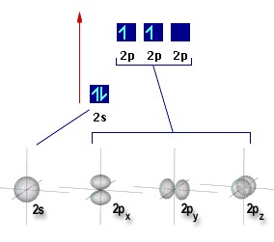

*Animation 6.29: Valence Bond Theory (VBT)*

*Source & Credit :*

[*chem.umas*](http://www.chem.umass.edu/)

[*s*](http://www.chem.umass.edu/)

1H = 1s

   

9 F = 2 s 2p 2p 2p*x* y *z*

The overlap of orbitals provides a means for sharing electrons, thereby allowing each atom to complete its valence shell. The luorine atom completes its 2p subshell by acquiring a share of an electron from hydrogen as shown below.

9 F = 2 s 2p 2p 2p*x* y *z*

The requirements for bond formation are met by overlapping the half-illed Is orbital of hydrogen with the half-illed 2p orbital of luorine. There are then two orbitals plus two electrons whose spins can adjust so they are paired. The formation of the bond is illustrated in Fig.(6.5)

The bond in the luorine molecule, F2 is formed by the overlap of half-illed 2pz orbital on each luorine atom,Fig (6.6).

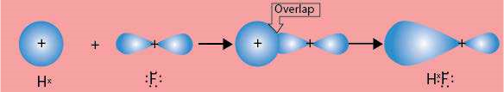

Fig. (6.5) The formation of the hydrogen luoride molecules.

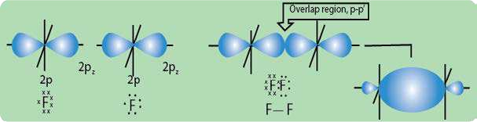

Fig.(6.6) The formation of the luorine molecule.

Covalent bonds can also form by side-to-side overlap of p orbitals, as shown in Fig.(6.7). The result is a pi (p) bond, in which the greatest electron density lies above and below the internuclear axis.

Consider, the bonding between nitrogen atoms having the electronic coniguration 1s 2s 2p 2p 2p2 2 *x* *y* *z* . The three unpaired electrons on each atom are located in perpendicular p orbitals, which are oriented so that if one end-to-end p orbital overlap occurs (resulting in a sigma bond), the other two p orbital cannot overlap in the same fashion. Rather, they are aligned parallel to the corresponding orbital in the other atom Fig(6.8).

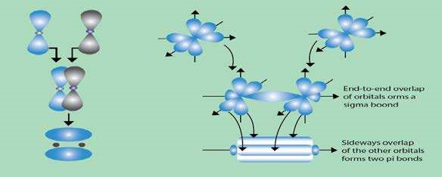

Fig. (6.7) The sideway overlap of two atomic Fig. (6.8) The two nitrogen atoms showing

p orbitals to give a n bond. one sigma bond and two n bonds

Now, let us look at the molecule of H2S. This is a non-linear molecule, and the bond angle between the two H-S bonds is about 92°.

Each two 3p orbitals of sulphur containing one electron can overlap with the 1s orbitals of hydrogen atoms.

    S = 3 s 3p 3p 3p*x* y *z*

Thus, the VBT requires the idea of overlap to explain the geometry of the hydrogen sulphide molecule, Fig. (6.9).

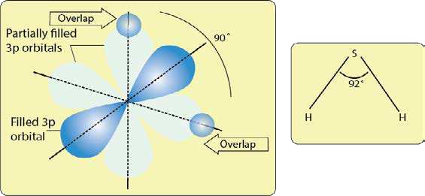

Fig. (6.9) Bonding in H2S showing overlap of orbitals

**6.4.5 Atomic Orbital Hybridization and Shapes of Molecules**

So far we have regarded overlap taking place between unmodiied atomic orbitals. Formation of some molecules present problems.

We face the problem of explaining equivalent tetra-valency of carbon and the bond angles in H2O and NH3 molecules. In order to explain the formation of bonds and shapes or geometry of molecules, the idea of hybridization has been introduced.

According to this, atomic orbitals difering slightly in energy intermix to form new orbitals, which are called hybrid atomic orbitals. They difer from the parent atomic orbitals in shape and possess speciic geometry.

The atomic orbital hybridization gives a satisfactory explanation for the valency of the elements. In some cases, the electrons belonging to the ground state are promoted to the excited state as a result of which there is an increase in the number of unpaired electrons.

These excited orbitals undergo hybridization simultaneously, because promotion of electrons and hybridization is a simultaneous process. The energy required for the excitation is compensated by the energy released during hybridization and the process of bond formation with other atoms. Hybridization leads to entirely new shape and orientation of the valence orbitals of an atom. It holds signiicant importance in determining the shape and geometry of molecules.

Depending upon the number and nature of the orbitals participating in hybridization, diferent types of hybridization take place. For example, s and p orbitals of simple atoms are hybridized to give sp3, sp2 and sp hybridized orbitals.

**(i) sp3 Hybridization**

In sp3 hybridization, one s and three p atomic orbitals intermix to form four equivalent orbitals called sp3 hybrid atomic orbitals. Let us discuss the structures of CH4 ,NH3 and H2O by understanding the sp3 hybridization of carbon, nitrogen and oxygen-atoms.

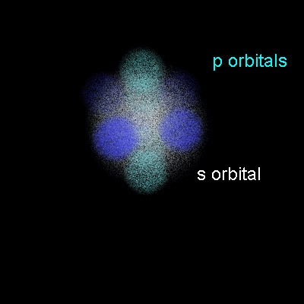

*Animation 6.30: Atomic Orbital Hybridization and Shapes of Molecules*

*Source & Credit : web.clark*

**Bonding and Structure of Methane, Ammonia and Water**

The electronic distribution of carbon atom should be kept in mind to understand intermixing of orbitals.Electronic coniguration of 6C, its electronic excitation and hybrization is giyen as follows.

    0

=

C6=(ground state) 1 s 2 s 2p 2p 2p*x y* z

    

C6=(excited state) =1 s 2s 2p 2p 2p*x y* z

    

C6=(hybridized state) 1 s sp sp sp sp3 3 3

= 3

The e nergies of hybrid orbitals are lower than unhybridized orbitals. Following diagram Fig.

(6.10) shows, how outermost four atomic orbitals of carbon mix up to give four hybrid orbitals of equal energy and shape. hen 90°.

The four new hybrid orbitals of equal energy have a tetrahedral geometry with carbon at the centre. The four equivalent hybrid orbitals are directed towards the four corners of a regular tetrahedron. Each sp3 hybrid orbital consists of two lobes, one larger and the other smaller. For the

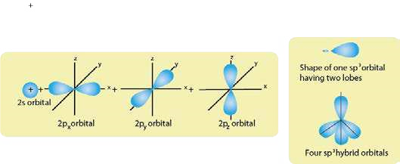

Fig (6.10) sp3 hybridization of carbon atom to give four sp3-hybrid orbitals

sake of simplicity, the small lobe is usually not shown while representing sp3 hybrid orbitals.

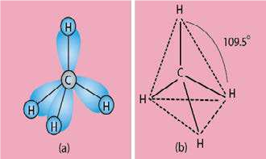The hybrid orbitals are oriented in space in such a manner that the angle between them is 109.5° as shown in Fig(6.11a,b). Methane molecule is formed by the overlap of sp3 hybrid orbitals of carbon with 1s orbitals of four hydrogen atoms separately to form four sigma bonds. The molecule, thus formed, possesses a tetrahedral geometry. The four C-H bonds which result from sp3 -s overlaps

are directed towards the corners of a regular Fig(6.11) Four sp3-s overlaps in tetrahedral structure of CH4 molecule.

tetrahedron. There are six bond angles each

109.5°. The tetrahedral structure of CH4 has four faces, four corners and six edges.

**(b) Ammonia**

To understand the sp3 hybridization of nitrogen-atom in NH3, we should know electronic coniguration of 7N.

N (ground state)=     

7 1 s 2 s 2p 2p 2p*x y* z

7N (hybridized state) =1 s sp sp sp sp3  3  3  3

One s and three p orbitals of nitrogen atom hybridize to form four sp3 hybrid atomic orbitals. They are directed towards the four corners of a tetrahedron. One of the hybrid orbitals is completely illed with electrons and the remaining three orbitals are half illed. The nitrogen atom undergoes three sp3-s overlaps with three s-orbitals of hydrogen atoms. The three hydrogen atoms are located at three corners whereas the lone pair of electrons is at the fourth corner of the tetrahedron. The result is a pyramidal molecule in which the three hydrogen atoms form the base and the lone pair of electrons the apex Fig(6.12).

The experimentally determined angle in ammonia is 107.5°. The deviation from the tetrahedral angle (109.5°) is explained on the basis of repulsion between the lone pair and the bond pairs of electrons. The lone pair is closer to the nucleus of nitrogen, then the bond pair and bond angles are decreased.

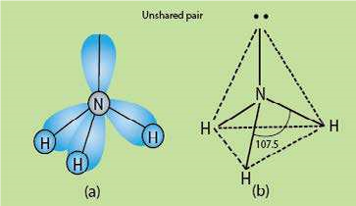

Fig (6.12) Three sp3- s overlaps in NH3 molecule to form a pyramidal structure.

**(c) Water, H20**

To know the structure of water write down the electronic coniguration of 8O:

O (ground state) =     

8 1 s 2 s 2p 2p 2p*x y* z

O (hybridized state)=      3

8 1 s sp sp sp sp3 3 3

Here, 2s and three 2p orbitals of oxygen hybridize to form four sp3 hybrid orbitals which will have a tetrahedral arrangement. Two hybrid orbitals are completely illed by the two available lone pairs of electrons. The remaining two half illed hybrid orbitals undergo sp3-s overlaps with H atoms to form two sigma bonds. The two H atoms occupy two corners of the tetrahedron and the remaining two are occupied by two lone pairs of electrons, Fig(6.13).

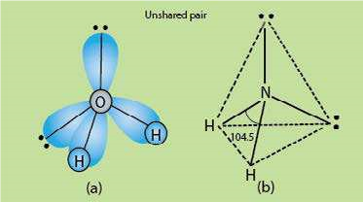

Fig (6.13) sp3-s overlaps in H20 to form an angular structure

The bond angle in water is 104.5°. The deviation from the tetrahedral angle (109.5°) is explained on the basis of repulsion between the two lone pairs of electrons, with bond pairs. The lone pairs are closer to the nucleus of oxygen. They repel bond pairs and the bond angle decreases from 109.5° to 104.5°. So, the molecule of water has bent or angular structure.

**(ii) sp2- Hybridization**

In sp2 hybridization, one ‘s’ and two ‘p’ atomic orbitals of an atom intermix three orbitals called sp2 hybrid orbitals.

#### Bonding and Structure of Boron Triluoride and Ethene (a) Boron Triluoride (BF3)

The three half illed sp2 hybrid orbitals are planar and are oriented at an angle of 120°, Fig(6.14). The sp2 hybridization explains the geometry of planar molecules such as BF3. Electronic coniguration of 5B is,

B (ground state)=    0 0

5 1s2s 2p 2p 2p*x x* z

B (excited state) =     0

5 1s 2s2p 2p 2p*x y* z

B (hybridized state)=    2

5 1s sp sp sp2 2

In sp2 hybridization, one s and two p atomic orbitals of an atom intermix to form three orbital called sp2 hybrid orbitals.

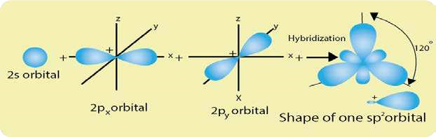

Fig (6.14) Three sp2 hybridized orbitals in one plane and at 120° to each other.

One of the p orbitals of luorine is half illed i.e. 2pz. This p-orbital of F is in the form of a lobe. BF3 is formed by the overlap of three half illed sp2 hybrid orbitals of boron with lobe shaped p-orbitals of three luorine atoms Fig.(6.15). The structure is triangular planer.

**(b) Ethene (CH2=CH2)**

Electronic coniguration of 6C is

C (ground state)=     0

6 1 s 2 s 2p*x* 2p*y* 2pz

    

6C (excited state)=1 s 2s 2p*x* 2p*y* 2pz

C (hybridized state)=     

6 1 s sp sp sp2 2 2 2p*z*

In the formation of ethene molecule, each carbon atom undergoes sp2 hybridization to form three hybrid orbitals which are co-planar and are oriented at an angle of 120°. Each atom is left with one half illed p-orbital perpendicular to the planar sp2 hybrid orbitals.

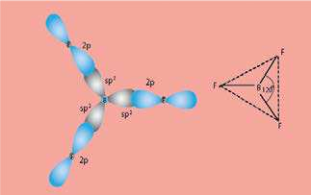

Fig. (6.15) sp2-p overlaps in BF3 to form triangular planar structure.

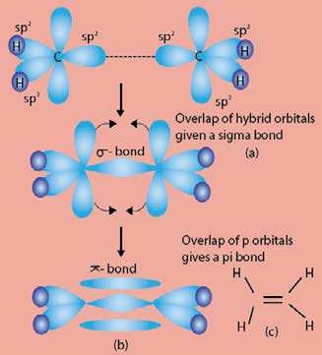One of the p-orbitals does not take part in hybridization. Each carbon atom undergoes sp2-s overlaps with two hydrogen atoms and sp2-sp2 overlap between themselves to form sigma bonds. These overlaps lead to the shapes shown in Fig.(6.16a). The partially illed p-orbitals undergo sidwrays overlap to form a p−bond.

So, a p-bond is formed by the sideways overlap of two half illed co-planar p-orbitals in such a way that the probability of inding the electron is maximum perpendicular to the line joining the two nuclei. It should be made clear that a p-bond is formed between two atoms only when they are already bonded with a sigma bond.

The two clouds of the p-bond are perpendicular to the plane in which ive p-bonds are lying. Just like s-bond, p -bond can be represented by a line as in Fig (6.16 b). The inal shape of C2H4 is shown in Fig. (6.16 c).

Fig. (6.16) Formation of one sigma between two carbon atoms and one p-bond in C2H4.

**(iii) sp-Hybridization**

In sp hybridization, one ‘s’ and one ‘p’ orbitals.intermix to form two sp-hybrid orbital called sp hybrid orbitals.

**Bonding and Structure of Beryllium Dichloride and Ethyne (a) Beryllium Bichloride**

Electronic coniguration of 4Be is

  0 0 0

4Be (ground state) =1 s 2 s 2p*x* 2p*y* 2pz

   0 0

=

4Be (excited state) 1 s 2s 2p*x* 2p*y* 2pz

  

4Be (hybridized state) =1 s spsp

The two sp hybrid orbitals lie in linear way, Fig (6.17). The sp hybridization explains the geometry of linear molecules such as beryllium chloride, BeCl2. It is formed when two sp hybrid orbitals of Be atom overlap with the half illed p-orbitals of chlorine atoms. The outermost half illed 3pz orbital of Cl has lobe shape.

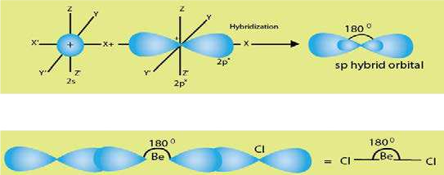

Fig. (6.17) sp-hybridization to form a linear structure

Be atom lies at the center and two Cl atoms on either side so that the Cl-Be-Cl angle is 180°.

**(b) Ethyne (CH=CH)**

The electronic coniguration of

    0

=

6C (ground state) 1 s 2 s 2p*x* 2p*y* 2pz

    

6C (excited state) =1 s 2s 2p*x* 2p*y* 2pz

  





6C (hybridized state)1 s sp sp2 2 2p 2p*y z* =

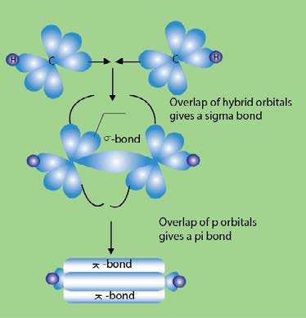Ethyne is formed as a result of sp hybridization of carbon atoms and subsequent formation of s and p bonds. Each carbon atom undergoes sp-s overlap with one hydrogen atom and sp-sp overlap with other carbon atom. Each carbon atom is left with two unhybridized p orbitals perpendicular to the plane of sp hybrid orbitals. The two half illed p orbitals (on separate carbon atoms) are parallel to each other in one plane while the other two p orbitals are parallel to each other in another plane. The sideways p overlap between the p-orbitals in two planes results in the formation of two p bonds as shown in Fig.(6.18).

Ethyne molecule contains one s and two p bonds between the two carbon atoms and each carbon atom

is bonded with, one H atom through s Fig. (6.18) Formation of one sigma and two pi-bonds in C2H2 (ethyne) bond. Actually, four electronic clouds of two p-bonds intermix and they surround the sigma bond in the shape of a drum.